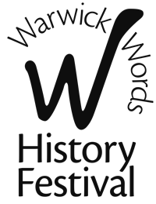

3 – 9 October 2022

PRESS RELEASE 23 March 2022
FOR IMMEDIATE RELEASE

Warwick Words History Festival Chosen to be Creative Partner

Warwick Words History Festival has become one of Warwick District Council’s
Creative Partners.

Festival Executive Director Helen Meeke said, ‘Warwick Words History Festival are delighted to have been appointed as Creative Partners with Warwick District Council for the next three years. As one of four arts organisations who have been selected to work in partnership with the WDC arts section, we are proud to share the ambitions of the Creative Framework and contribute to the development of our thriving creative sector. The Festival has run for 20 years and plays a significant role the in the cultural life of Warwick, both in terms of history programming, and in engaging local and visiting audiences.’

This year’s Warwick Words History Festival runs from 3 – 9 October 2022 at various venues in the town.

For further information about Warwick Words History Festival and to join the Festival’s mailing list please see www.warwickwords.co.uk

ENDS
Contacts for further information –
Helen Meeke 07944 768607
info@warwickwords.co.uk
www.warwickwords.co.uk

